Verdis Moorer
CSD-310
Module 7-Moview: updates & deletes
9/18/2026
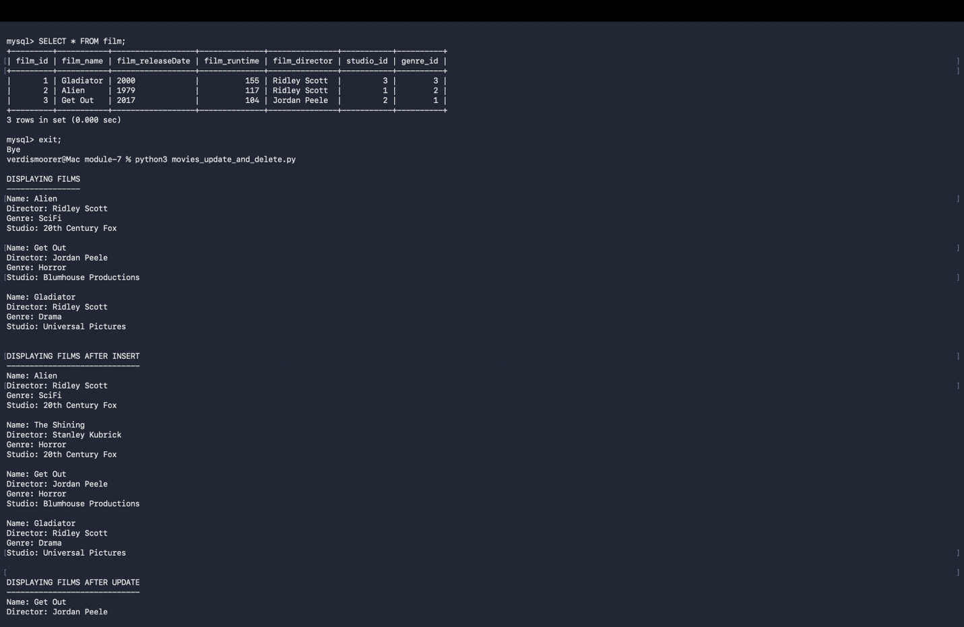



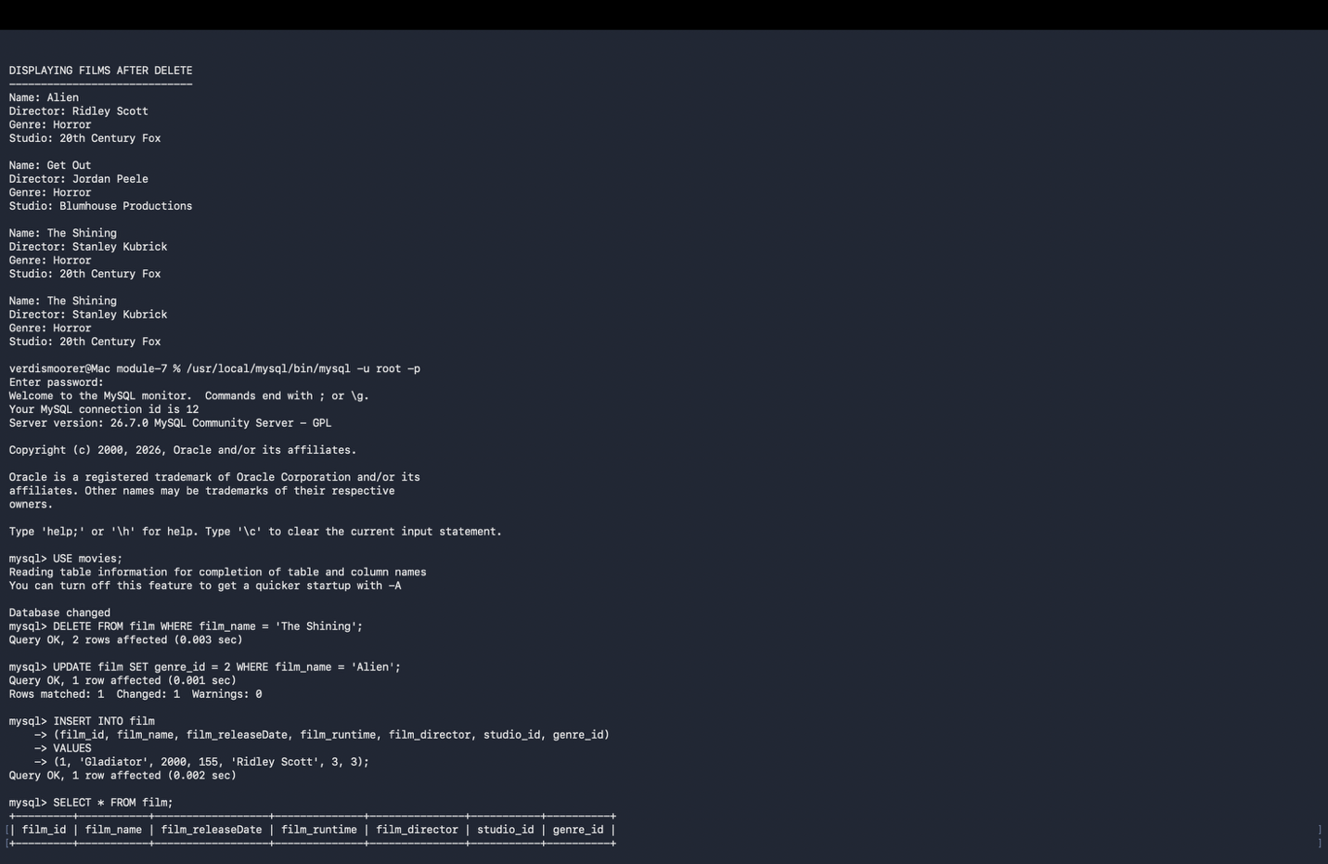



Github Repository
https://github.com/Verdis426/CSD-310

